**RAJALAKSHMI ENGINEERING COLLEGE**

**RAJALAKSHMI NAGAR, THANDALAM – 602 105**



|  |
| --- |
| **CS23A34**  **USER INTERFACE AND DESIGN LAB** |
| **Laboratory Observation Notebook** |

**Name :** Savita Shri G

# Year/Branch/Section : II/CSE/F Register No. : 230701299

# Semester : IV

# Academic Year: 2024-25

**Ex. No.: 8.b**

**Register No.: 230701299 Name: Savita Shri G**

**Develop low-fidelity paper prototypes for a banking app and convert them into digital wireframes using Inkscape**

**AIM:**

The aim is to construct low-fidelity paper prototypes for a banking app and digitize them into wireframes using Inkscape.

**PROCEDURE:**

**Tool Link: https://inkscape.org/**

Step 1: Create Low-Fidelity Paper Prototypes

1. Identify Core Features:
   1. Determine the essential features of the banking app (e.g., login, dashboard, account management, transfers).
2. Sketch Basic Layouts:
   1. Use plain paper and pencils to sketch the main screens.

○ Focus on the primary elements like buttons, navigation menus, and input fields.

1. Iterate and Refine:
   1. Get feedback from users or stakeholders.

○ Make necessary adjustments to improve clarity and functionality.

Step 2: Convert Paper Prototypes to Digital Wireframes Using Inkscape

1. Install Inkscape:

○ Download and install Inkscape from the official website.

1. Create a New Document:
   1. Open Inkscape and create a new document by clicking on File > New.
2. Set Up the Document:
   1. Set the dimensions and grid for your design. Go to File > Document Properties to adjust the size.

○ Enable the grid by going to View > Page Grid.

1. Draw Basic Shapes:
   1. Use the rectangle and ellipse tools to draw the basic shapes for your UI elements (e.g., buttons, input fields, icons).
2. Add Text:
   1. Use the text tool to add labels and placeholder text to your elements.
3. Organize and Align:
   1. Arrange and align the elements to match your paper prototype.

○ Use the alignment and distribution tools to keep everything organized.

1. Group Elements:
   1. Select related elements and group them together using Object > Group.

○ This helps keep your design organized and easy to edit.

1. Create Multiple Screens:
   1. Duplicate your base layout to create different screens (e.g., login, dashboard, transfer).

○ Use Edit > Duplicate to create copies of your elements and arrange them for each screen.

1. Link Screens (Optional):
   1. If you want to show navigation flows, you can add arrows or other indicators to demonstrate how users will move between screens.

10.Export Your Wireframes:

○ Once you're satisfied with your digital wireframes, export them by going to File

> Export PNG Image.

○ Choose the appropriate settings and export each screen as needed. **OUTPUT:**

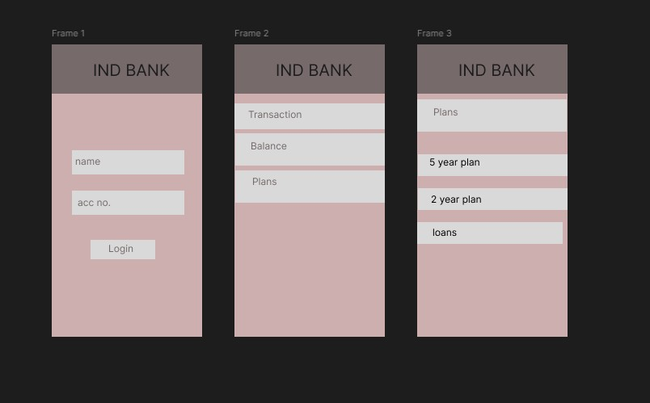

**RESULT:**

Hence low-fidelity paper prototypes for a banking app and digitize them into wireframes using Inkscape is constructed.